|  |
| --- |
| 新东方在线英语学习 |
| 新概念 3 册 |
| Lesson36 |

Lesson 36 A chance in a million

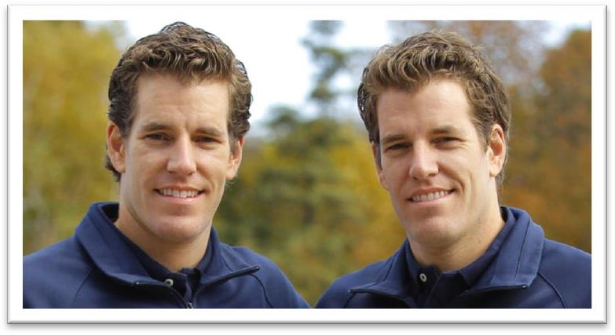

**credulous ['kredjələs] adj. 轻信的**

Anna is so credulous that she’ll believe anything you tell her. naïve

“cred” = believe

credit n. 信用；赊账 credit card credulous incredulous

credible incredible

credentials n. 证书；证件

obscure [əb'skjʊə(r)]

**adj. 不起眼的，不出名的； 难以理解的**

obscure: 1. unknown; little-known an obscure little village

an obscure maidservant remain obscure

The environment is obviously important, but its role has remained obscure. well-known; famous; noted; notable; eminent; celebrated; renowned

obscure: 2. hard to understand

Very few people could understand his lecture because it was very .

(A) faint (B) obscure

(C) gloomy (D) indefinite

presume [pri'zju:m]

**v. 假定，推测，认为**

From the way they talked, I presumed (that) they were a couple. be presumed dead / innocent …

A long-lost brother, who was presumed dead, was really alive all the time and wickedly plotting to bring about the hero's down-fall.

You are presumed innocent until you are proved guilty. believe think suppose assume

… a German taxi driver, Franz Bussman, found a brother who was thought to have been killed twenty years before.

Everyone went to the funeral, for the 'ghost' was none other than Eric Cox, a third brother who was supposed to have died as a young man.

be under the impression that …

还以为……

Though the crew were at first under the impression that the lost ship had been found, the contents of the chest proved them wrong.

take it for granted that …

想当然地认为……

You can’t take it for granted that the children will behave themselves.

plot [plɒt]

**v. 秘密谋划，暗中策划**

plot to do = scheme to do

The criminal was plotting / scheming to rob the bank. conspire to do

The criminals were conspiring to rob the bank.

Bad weather and car trouble conspired to ruin our vacation.

resemblance [ri'zembləns]

**n. 相似**

resemble

She closely resembles her mother in every way. resemblance

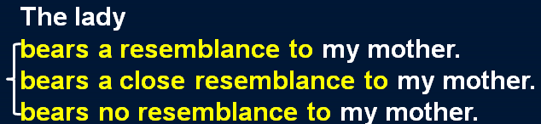bear a resemblance to …

Your school may have done away with winners and losers, but life has not.

In some schools they have abolished failing grades; they'll give you as many times as you want to get the right answer. This doesn't bear the slightest resemblance to anything in real life. **acquaint [ə'kweɪnt]**

v. 使熟悉或了解

be / get / become acquainted with … I’m not acquainted with him.

He became acquainted with the work. be / get / become familiar with …

He was familiar with the work. The work was familiar to him. acquaintance

He is my only acquaintance in the little town.

reunite [ri:ju:'naɪt]

**v. 使团聚**

be reunited with …

The lost children were reunited with their parents. reunify

reunification national reunification

I'd love to buy a Rolls-Royce, but it costs an arm and a leg. Everybody was clapping their hands off.

I didn’t sleep a wink last night. He has a skeleton of a wife.

We are less credulous than we used to be.

We spend more time traveling than we used to. less + adj. / adv. + than …

not so / as + adj. / adv. + as …

We are not so / as credulous as we used to be. 造句：他不像以前那么内向 (introverted)了。He is less introverted than he used to be.

He is not so / as introverted as he used to be.

造句：他英语说的不如以前好了。

He speaks English less well than he used to.

He doesn't speak English so / as well as he used to.

In the 19th century, a novelist would bring his story to a conclusion by presenting his readers with a series of coincidences — *most of them wildly improbable*.

would 和 used to do 类似，都可以表示过去习惯性的动作，如：One day in a week he would spend a whole day in silence. 但注意：would 不能用在故事开头，往往在故事开头用 used to do，而后面换为 would do，如：We used to work in the same office and we would often have coffee together.

bring sth. to a conclusion

The two countries decided to bring the war to a conclusion.

come to / arrive at / reach / draw a conclusion bring sth. to a close / an end

The rally was brought to a close / an end by the singing of the national anthem. end / close / conclude …

…, a novelist would end / close / conclude his story by … bring … to …

It was the war that first brought him to power.

So far the US has been unable to bring him to justice.

present sb. with sth. present sth. to sb.

He entered the cell and presented the letter to the aristocrat. an unforeseen series of catastrophes

a series of ... a chain of ...

a train of ... a trail of ...

a string of ... a stream of ... by coincidence

My mother is called Anna, and by coincidence my wife's mother is called Anna too. coincide with sth.

My arrival coincided with his departure.

If our schedules coincide, we'll go to Shanghai together. His tastes and habits with those of his wife.

combine

compete

coincide

compromise

It is fortunate for the old couple that their son’s career goals and their wishes for him .

coincide

comply

conform

collaborate

most of them being wildly improbable.

most of them were wildly improbable. X

and / but most of them were wildly improbable. √

most of which were wildly improbable. √

Apart from an interesting-looking carved dagger, the box was full of crockery, much of it broken. Apart from an interesting-looking carved dagger, the box was full of crockery, and / but much of it was broken.

Apart from an interesting-looking carved dagger, the box was full of crockery, much of which was broken.

造句: 考古学家发现了十五尊雕像, 每一尊代表着一位女神。

The archaeologists found fifteen statues, each of them representing a goddess.

A long-lost brother, who was presumed dead, was really alive all the time and wickedly plotting to bring about the hero's downfall.

be presumed dead / innocent …

Their nephew was missing, presumed dead.

In English law, an accused man is presumed innocent until he is proved guilty.

He may hunt, beg, or steal occasionally to keep himself alive, … living all living things living proof

At such times, justice acts like a living force. live

experiments on live animals be transmitted live

Is the wire live?

… and wickedly scheming to…√

… and wickedly conspiring to… X

a plot to assassinate the President

scheme intrigue conspiracy

schemes and intrigues

All the imperialist schemes and intrigues are doomed to failure. downfall n. 1. fall from a position of prosperity or power

Greed led to his downfall.

downfall n. 2. thing that causes this His vanity was his downfall. undoing

The team's weak defense was their undoing.

That proved to be my undoing, for I soon got back to my old bad habit of dozing off in front of the screen.

and so on and so forth and the like and what not

etc. (et cetera)

Modern readers would find such naive solutions *totally unacceptable*. improbable

incredible unbelievable inconceivable unconvincing preposterous

造句：中国学生会觉得这么简单的考试是完全无法相信的。

Chinese students would find such easy examinations totally incredible.

Though the crew were at first under the impression that the lost ship had been found, the contents of the chest proved them *wrong*.

造句：事实证明他们的担心是多余的。The facts proved their worries *unnecessary*. 造句：事实证明他的指责毫无根据。

The facts proved his accusation *totally groundless*.

If you lived in the Mediterranean, for instance, you would consider octopus *a great delicacy*.

造句：如果你住在北京，你就会把豆汁儿 (Douzhir) 当作一道美味佳肴。

If you lived in Beijing, you would consider Douzhir *a great delicacy*.

造句：如果你住在中国东北地区 (the Northeast of China)，你就会非常喜欢滑冰。If you lived in the Northeast of China, you would consider skating *a great pleasure*.

*Yet*, in real life, circumstances do sometimes conspire to bring about coincidences which anyone but a 19th century novelist would find incredible.

in real life

in the real world

Under no circumstances *should* you approach that man.

Due to circumstances beyond our control, … conspire to do sth.

Falling demand and high interest rates have conspired to produce a big drop in profits.

Nobody but Robert would do such a thing. Who but a fool would do such a thing?

His house is the last but one in the street. Take the next turning but one on your left. nothing but = only

He is nothing but a thief. anything but = not at all He is anything but a hero. He is anything but stupid. all but = almost

Britain's coal industry has all but disappeared. His left arm was all but useless.

but 后可跟不定式 (to) do

We have nothing to do but wait here. We have no choice but to wait here.

造句：在现实生活中，有时确实很多情况会凑到一起导致一连串的大灾难，而这些事情除了受害者之外可能谁也不会相信。

In real life, circumstances do sometimes conspire to bring about a series of catastrophes which anyone but the victims would find incredible.

*When I was a boy*, my grandfather told me how a German taxi driver, Franz Bussman, found a brother *who was thought to have been killed twenty years before*.

When a boy, … X

In my childhood, … In my early years, … In my teens, …

In my adolescence, … In my youth, …

Everyone went to the funeral, for the 'ghost' was none other than Eric Cox, a third brother who was supposed to have died as a young man.

Stop to smell the flowers.

I’m exhausted. Let’s stop to smoke.

Please stop smoking. Smoke really bothers me. cease to do / doing

After they had gone on, Mrs. Bussman commented on *the workman's close resemblance to her husband* and even suggested *that he might be his brother*.

comment on …

I don’t want to comment on other people’s views. No comment.

comment that …

remark on … remark that … bear a close resemblance to … closely resemble …

Mrs. Bussman commented / remarked that the workman bore a close resemblance to her

husband / closely resembled her husband.

The workman and her husband were extraordinarily similar / particularly alike. The workman and her husband had a lot in common.

There were striking similarities / was considerable commonality between the workman and her husband.

Franz poured scorn on the idea, pointing out that his brother had been killed in action during the war.

pour scorn on … pour contempt on … pour ridicule on … pour cold water on …

Franz didn’t take the idea seriously.

…, reminding her that his brother had been killed …

I must point out that you are making a dangerous mistake.

At this, the police pointed out ironically that this would hardly be necessary as the men were already under arrest.

His father told everybody that Eric had been killed in action.

Though Mrs. Bussman was fully acquainted with this story, she thought *that there was a chance in a million that she might be right*.

be acquainted with … be familiar with …

Though Mrs. Bussman was fully familiar with this story, …

…, she thought there was the slightest / remotest chance that she might be right.

造句：尽管这位侦探非常了解这位老太太对周围每一个人总是这么好，但他认为仍有一丝可能这位老太太就是谋杀犯。

Though the detective was fully acquainted with the fact that the old lady was always so kind to everybody, he thought that there was a chance in a million that she might be the murderer. needless to say

as you can imagine

Needless to say our house is now surrounded by a jungle.

When the brothers were reunited, Hans explained *how it was that he was still alive*. how it was: how it happened

造句：当 Eric 回到农场后，他解释了他是怎么从团里逃出来的。

When Eric returned to the farm, he explained how it was that he deserted his regiment.

After he had been wounded, … towards / toward midnight

Towards midday, a girl heard a muffled cry coming from behind one of the walls. send sb. to hospital

take sb. to hospital be in hospital

be hospitalized

be out of / leave hospital

A man who had broken his right leg was taken to hospital a few weeks before Christmas.

To compensate for his unpleasant experiences in hospital, the man drank a little more than was good for him.

The following day, however, the doctor consoled him by telling him that his chances of being able to leave hospital in time for New Year celebrations were good.

separate … from …

Theory should never be separated from practice.

cut … off from …

She realized that he was trying to cut her off from her friends.

isolate … from …

He was isolated from all the other prisoners.

segregate … from …

Blacks were segregated from whites in every area of life.

make one’s way 前往某地

I made my way *to the house*.

I made my way *into the backyard*. I made my way *along the river*.

I made my way *up the stairs*.

Turning back down the main street, we quickened our pace and made our way rapidly *towards the stream* where we hoped the boatman was waiting.

feel one’s way

The room was dark, so I had to feel my way along the wall to the door.

edge one’s way

They had to edge their way along this, sometimes wading across shallow streams, or swimming across deep pools.

force / elbow one’s way

He forced / elbowed his way through the crowd. find one’s way

Very few of the fifty pence pieces and pound coins I have given him have found their way there. wind / trace one’s way

The river winds its way through the valley.

We expected the path to end abruptly, but we found that it traced its way through the trees. Hans returned to his family home, but the house had been bombed and no one *in the neighbourhood* knew what had become of the inhabitants.

become of sb. / sth.

What has become of Jane?

Whatever became of the parcel you sent?

No one in the neighborhood knew his family’s whereabouts.

Despite numerous searches and enquiries, her whereabouts are still unknown.

inhabitant inhabit

In the future people may inhabit other planets.

cohabit with … cohabitant habitat

Assuming that his family had been killed during an air raid, Hans settled down in a village 50

miles away *where he had remained ever since*. assuming (that) … 以为；假定，假如

Assuming (that) the man was making a homosexual advance, he stormed out of the house angrily.

Assuming (that) the house is for sale, would you buy it?

You can stretch your legs on the spacious decks, play games, swim, meet interesting people and enjoy good food—always assuming, of course, that the sea is calm.

even assuming (that) … = even if …

Even assuming (that) smokers do see the health warnings, I doubt they'll take any notice. settle down

He had often dreamed of retiring in England and had planned to settle down in the country.

…, Hans settled down *in a village 50 miles away* and he had remained *there* ever since.